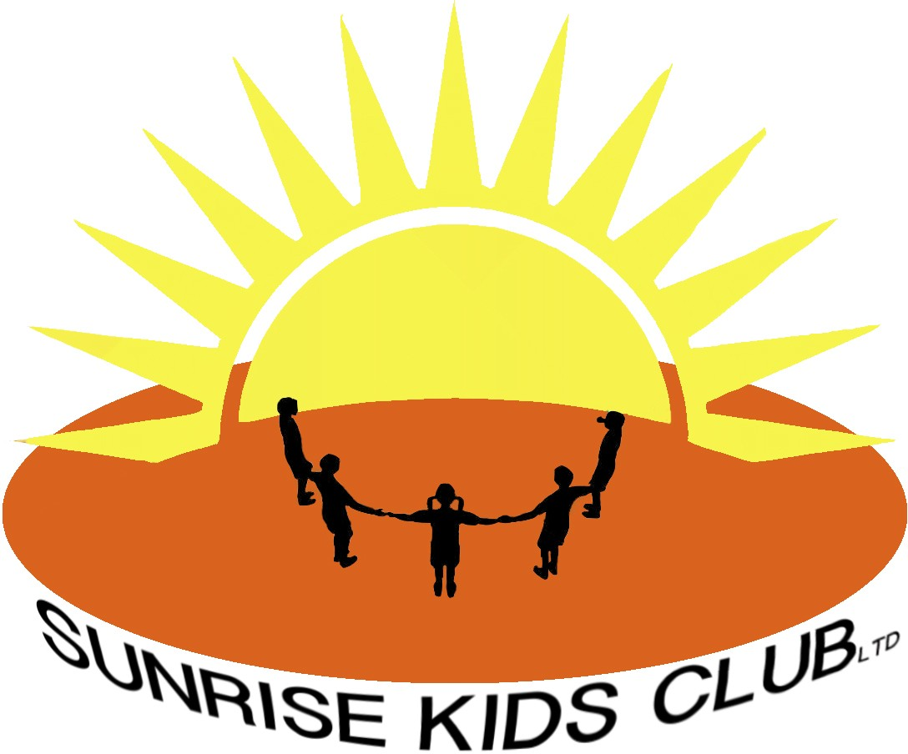

Pandemic Flu Policy
Sunrise Kids Club recognises the importance of advanced planning in order to maintain services and limit the spread of pandemic flu within our setting.

Flu is a viral infection, spread from person to person by close contact. Symptoms may include:

Sudden fever Sudden cough Headache Tiredness Chills Aching muscles
Limb and joint pain Diarrhoea or stomach upset Sore throat Runny nose Sneezing Loss of appetite
Any child who becomes ill with symptoms which could be pandemic flu while at the Club will be isolated from the other children until the child can be collected by his or her parents. The Club will remain open but parents and staff will be informed, especially those in high-risk groups.

Any children or staff who are experiencing symptoms of pandemic flu should stay away from the Club until all symptoms have passed and they feel well.

Infection control

The flu virus is spread by:

- Infected people passing the virus to others through large droplets when coughing, sneezing, or even talking within a close distance (one metre or less).

- Direct contact with an infected person: for example, if you shake or hold their hand, and then touch your own mouth, eyes or nose without first washing your hands.

- Touching objects (eg door handles, light switches) that have previously been touched by an infected person, then touching your own mouth, eyes or nose without first washing your hands. The virus can survive longer on

hard surfaces than on soft or absorbent surfaces. We will limit the risk of catching or spreading the flu virus at the Club by:

  - Regular hand-washing

  - Minimising contact between our hands and mouth/nose

  - Covering nose and mouth when coughing or sneezing; using a tissue when possible, and disposing of the tissue promptly and carefully (bag it and bin it)

  - Encouraging the children at the Club to follow the guidance above

  - Instructing staff to remain at home if they display any relevant symptoms, or sending them home if they first display symptoms while at work. At Sunrise Kids Club we will promote infection control through the methods above, and in addition we will:

    - Display posters and information to promote infection control

    - Ensure that adequate supplies of cleaning materials are available within the Club

    - Dispose of waste promptly and hygienically

    - Clean hard surfaces (eg door handles) with sanitizer regularly

    - Provide tissues and suitable facilities for their disposal.

Closure

The latest scientific advice is that closing individual settings is of limited benefit in stopping the spread of the disease. However, there may be some occasions when we will have to consider temporarily closing the Club because we have too few unaffected staff to run sessions safely. If this occurs the manager will contact Ealing Early years childcare services for further support and guidance.

The Club will also have to close if advised to do so by the local authority in the interest of safeguarding the children in our care.

In the event of closure, the manager will notify parents or carers as soon as possible. The manager will also inform the local childcare information service as well as other relevant parties, eg feeder schools, other users of shared premises, etc. The manager will also notify Ofsted of the closure.

Advance planning

In preparation for dealing with a pandemic disease, the Club will ensure that all contact details for staff, children and parents are up to date.

We will prepare letters of notification for parents and staff, so that they can be distributed as soon as an outbreak occurs.

We will also ensure that we have adequate measures in place to help support staff or children who are dealing with bereavement.

We will endeavour to build a bank of relief or supply staff who are able to provide cover should staffing levels fall below the required legal minimums. Any relief staff will be CRB checked at the time of joining our team, so that they are legally able to work with children should the situation arise.

The Club will regularly update its information regarding pandemic diseases, by checking the latest guidance from DfE and the local authority, and will inform parents and staff of any changes to our emergency plans.

Useful contacts

Early Years or Childcare Service: (020) 8825 5588 Ofsted: 0300 123 1231

Written in accordance with the Statutory Framework for the Early Years Foundation Stage (2012): Safeguarding and Welfare Requirements: Health [3.42]

This was adopted by Sunrise Kids Club Ltd

Last reviewed January 2023

