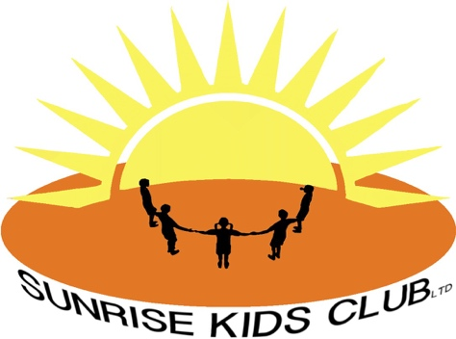

Behavior Management Policy and Procedure

At Sunrise Kids club (SKC) we believe that by encouraging respect and understanding towards all members of our community, the attitudes formed by our children will be transferred to outside of school, their adult world of work and home life, fostering positive, harmonious and enjoyable relationships.
All children irrespective of age, disability, gender reassignment, (marriage and civil partnership, pregnancy and maternity) race, religion or believe, gender, sexual orientation, social economic status have an entitlement to effective learning experiences which will enable them to achieve their maximum potential.

Aims:

- To encourage a calm and happy atmosphere within the club
- To foster caring attitudes towards everyone and encourage positive relationships between peers and adults
- To encourage self-control, respect for others, respect for the setting and its resources and other people’s property
- To promote a consistent approach to behavior and discipline throughout the club with parental co-operation and involvement
- To raise awareness of appropriate behavior and make clear boundaries of acceptable behavior
- To ensure effective health and safety
- To help pupils, staff and parents have a sense of direction and a feeling of common purpose
- To improve standards of behavior within the club
- To inform staff and parents of the outcomes of inappropriate behavior in the setting or playground
- To create a consistent approach to behavior management across the club through time out areas in the playground and settings

Behavior on attendance:
- Punctuality
- Preparedness
- Politeness
- Engagement
- Respect for self and others
- Honesty

We do not allow behavior that involves bringing objects into the club that are banned or dangerous and disrespect for people or things.

Children’s responsibilities are to behave appropriately so that they:
- Work to the best of their abilities, and allow others to do the same
- Treat others with respect
- Follow instructions from staff
- Take care of property and the environment in and out of the club
- Co-operate with other children and adults
- To treat everyone fairly and with respect

Staff and parents work together by:
- Being consistent with children’s behavior
- To treat everyone- both children and adults fairly and with respect
- To raise the self-esteem of others to help them to develop their full potential.

Staff responsibilities:
- To treat everyone -both children and adults fairly and with respect
- To raise the self-esteem of others
- To provide a challenging and creative setting
- To create an environment that is physically and emotionally pleasant, safe and secure
- To be a good role model
- To recognise each person as an individual
- To be aware of each child’s needs
- To report any incidence of intimidation, aggressive or confrontational behavior by children or adults to the manager. The member of staff and any witnesses will complete and incident report as soon after the event as possible. The manage will follow up any further action following the advice from the LEA Personnel department.

Parent and carer responsibilities are:
- To follow LA advice and guidance that sets out an expected code of behavior for parents/carers to follow
- To make children aware of the appropriate behavior in all situations
- To encourage independence and self-discipline
- To show an interest in what their child does at SKC
- To foster a positive relationship with the club so that all children can see that the key adults in their lives share a common aim
- To be aware of the club rules and expectations
- To support the club in the implementations of this policy
- To treat staff with mutual respect
- Parents are expected to aid the smooth running of the club by following SKC procedures and policies
- The club will exercise their right to ban adults who exhibit violent, threatening behavior and abuse, verbal or physical, against staff or other members of the community from the premises.

Reviewed January 2026

