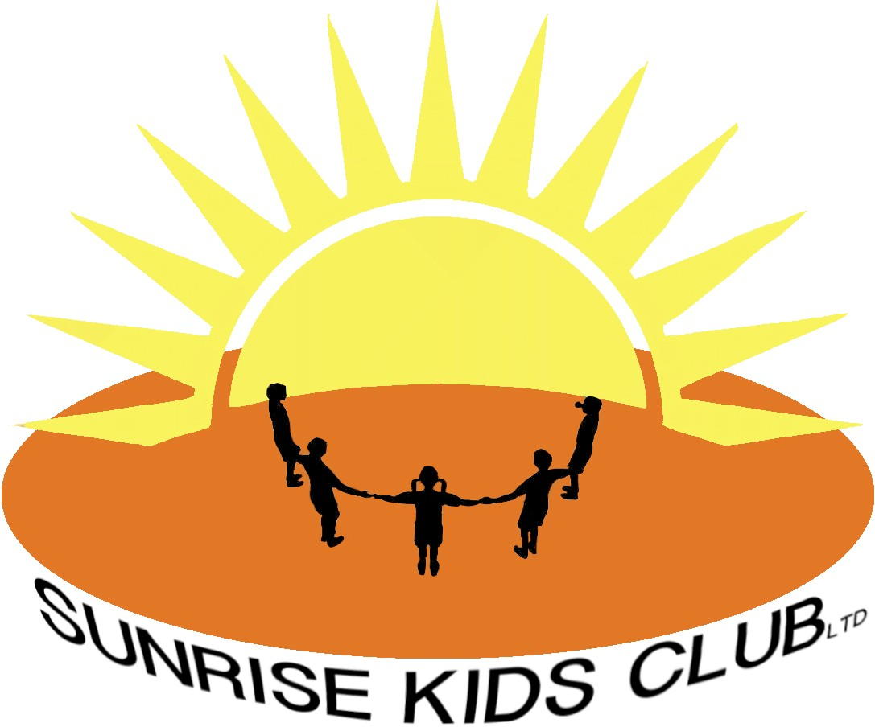
No Smoking, Drug and Alcohol Policy

Sunrise Kids Club LTD (SKC) condones neither the misuse of drugs and/or alcohol by staff nor the illegal supply of these substances.

In addition to the prohibition of drugs and alcohol SKC has a no smoking ethos as this will also have an indirect impact on the health of the children within our care.

The club is committed to the health and safety of its staff and children and will take action to safe guard their well-being. (see also Safeguarding and Child Protection Policy).

The Sunrise Kids Club (SKC) acknowledges the importance of its pastoral role in the welfare of young people, and adheres to the principals of safeguarding and every child matters. Through the general ethos of the Sunrise Kids Club (SKC) we will see to persuade pupils in need of support to come forward.

Last reviewed January 2023

