of registration
Certificate
raising standards improving lives

Registration Number: EY484186

Sunrise Kids Club Ltd 8822263 is registered as a provider of childcare on non­ domestic premises on the Early Years Register, the compulsory part of the Childcare Register and the voluntary part of the Childcare Register at:

Sunrise Kids Club Ltd Mayfield Primary School High Lane
London
W73RT

The registered provider must comply with the requirements for the Early Years Register set out in the Statutory Framework for the Early Years Foundation Stage. This includes a requirement to give parents information about their provision. The Early Years Foundation Stage is available at: www.foundationyears.org.uk/early­ years-foundation-stage-2012

The registered provider must comply with the requirements for the Childcare Register. For more information, please go to the relevant factsheet.

- Childcare on domestic and non-domestic premises - www.ofsted.gov.uk/crfs-cc

For more information about registered providers, please go to the relevant pages in the early years and childcare section of our website.

- Parents - www.ofsted.gov.uk/forparents
- Day care, including childcare on domestic premises and out-of-school provision - www.ofsted.qov.uk/fordaycare

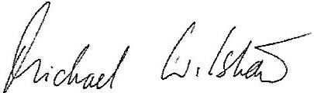
Sir Michael Wilshaw
Her Majesty's Chief Inspector
Date of registration:

Date of issue:

07/01/2015

07/01/2015

To contact Ofsted please telephone 0300 123 1231
(17916075)

