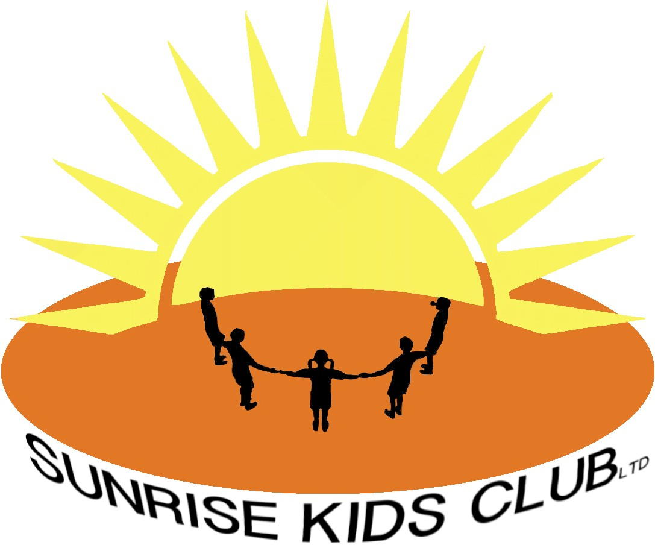

Behavior Management Policy and Procedure

At Sunrise Kids club (SKC) we believe that by encouraging respect and understanding towards all members of our community, the attitudes formed by our children will be transferred to world outside/ their adult world of work and family will be positive, harmonious and enjoyable.

Aims of this policy:

- To encourage a calm, purposeful and happy atmosphere within the club
- To foster positive, caring attitudes towards everyone where achievement at all levels are acknowledged and valued
- To encourage self control, respect for others; respect for setting resources, other peoples property and our clubs environment so that each child learns to accept responsibility for his/her own
- To promote a consistent approach to behavior and discipline throughout the club with parental co-operation and involvement
- To raise awareness of appropriate behavior an d make boundaries of acceptable behavior clear
- To ensure effective health and safety
- To help pupils , staff and parents have a sense of direction and a feeling off common purpose
- To promote a need for the children to feel safe
- To improve standards of behavior within the club
- To inform staff and parents of the outcomes of inappropriate behavior in the setting or playground.
- To create a consistent approach to behavior management across the club through time out areas in the playground and settings.

All children irrespective of age, disability, gender reassignment, (marriage and civil partnership, pregnancy and maternity) race, religion or believe, gender, sexual orientation, social economic status have an entitlement to effective learning experiences which will enable them to achieve their maximum potential.

Behavior on attendance:
- Punctuality
- Preparedness
- Politeness
- Engagement
- Respect for self
- Respect for others
- Respect for nature
- Respect for things
- Honesty
- Self control

We do not allow behavior that involves bringing objects into the club that are banned or dangerous and disrespect for people or things.

Children’s responsibilities are to behave appropriately so that they:
- Work to the best of their abilities, and allow others to do the same
- Treat others with respect
- Follow instructions of all staff
- Take care of property and the environment in and out of the club
- Co-operate with other adults and children
- To treat everyone - both children and adults fairly and with respect.

Staff and parents work together by:

- Being consistent with children’s behavior
- To treat everyone- both children and adults fairly and with respect
- To raise the self esteem of others- both children and adults and to help them to develop their full potential.

Staff responsibilities are:

- To treat everyone -both children and adults fairly and with respect
- To raise the self esteem of others –both children and adults and to help them to develop to their full potential;
- To provide a challenging and creative setting
- To cerate an environment that is physically and emotionally pleasant, safe and secure
- To be a good role model
- To recognize that each persons is an individual
- To be aware of each child’s needs
- To offer a framework for social education
- To report any incidence of intimation, aggressive or confrontational behavior by children or adults to the manager. The member of staff and any witnesses will complete and incident report as soon after the event as possible. The manage will follow up any further action following the advise from the LEA Personnel department.

Parents’ and corers’ responsibilities are:

- We follow LA advice and guidance and the LA have set out an expected code of behavior for parents / corers to follow
- To make children aware of the appropriate behavior in all situations
- To encourage independence and self discipline
- To show an interest in what their child does at Sunrise Kids club (SKC)
- To foster a positive relationship with the club so that all children can see that they key adults in their lives share a common aim
- To be aware of the club rules and expectations
- To offer a framework for social education
- To support the club in the implementations of this policy
- To treat staff wit mutual respect
- Parents are expected to aid the smooth running of the club by following the Sunrise Kids club (SKC) procedures and policies
- The club will exercise their right to ban adults who exhibit violent, threatening behavior and abuse, verbal or physical, against staff or other members of the community from the premises.

Last reviewed January 2023

