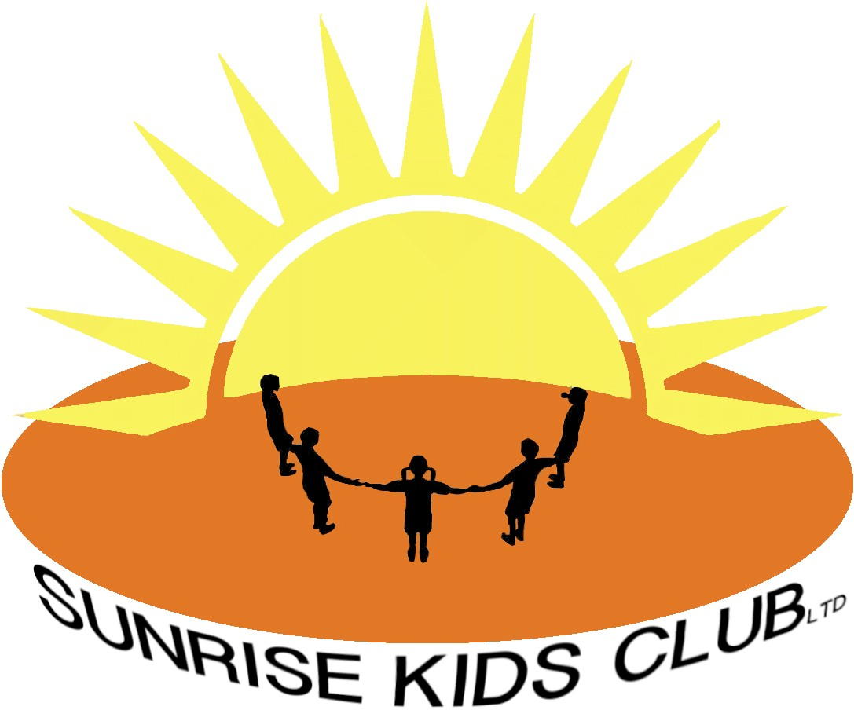

Food and Drink Policy

All food and drink will be prepared by staff who have attended a food hygiene course, the food is prepared in a clean and safe environment.

The food preparation area is cleaned before and after every use and the staff are to make sure a high level of cleanliness as this is paramount at all times.

There is a snack menu provided for the parents to view on the Sunrise Kids Club (SKC) noticeboard.

Children’s allergies and preferences are taken into consideration when providing snacks.

Allergies are recorded on the child’s registration form and displayed in the food preparation area.

Snacks that are provided are always of a healthy nature, Sunrise Kids Club (SKC) promotes healthy eating and we teach the children the importance of having a healthy diet.

Last reviewed January 2023

