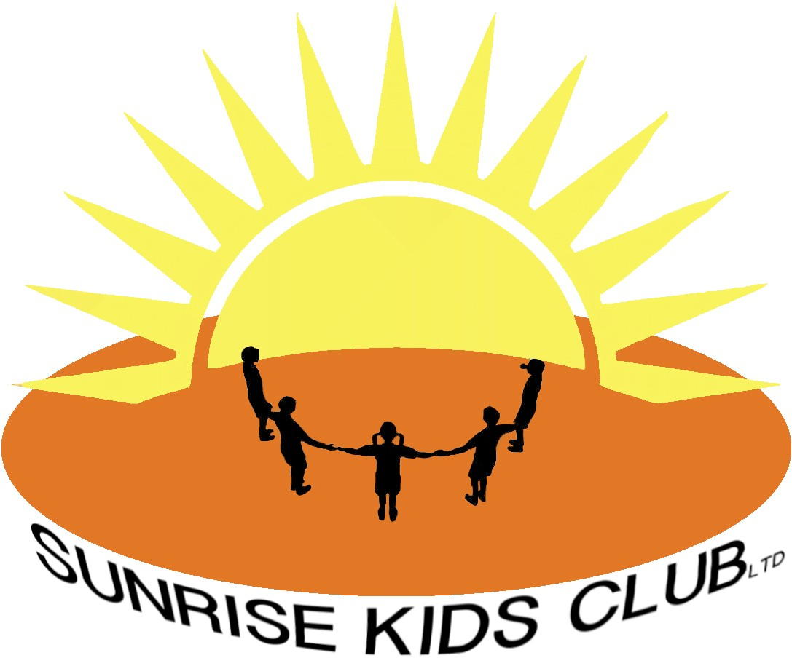
Accident, Illness and Injury Policy

Sunrise Kids Club (SKC) is committed to the safeguarding of all children and this is considered of paramount importance to all involved. Parents send their children to SKC each day with the expectation that SKC will provide a secure and safe environment in which their children can flourish. However there may be occasions whilst at SKC that a child may become ill or suffer an injury. Although SKC will ensure to prevent such occurrences it is inevitable that all incidents are not avoidable.

In the event that a child becomes ill or injured during SKC care, an SKC staff member will bring this to the attention of the club manager who is paediatric first aid trained.

If the child becomes ill due to an ongoing illness where previously agreed and authorised medication is necessary the administration of medication policy will be adopted.

If the child becomes ill or injured for another reason an initial examination of the child’s condition will be conducted and the child given first aid as appropriate. If it is apparent that this is a serious illness / injury then the London ambulance service will be contacted as well as the parent / carer [details taken from the child’s registration form]. An SKC staff member will accompany the child to the hospital until the arrival of the child’s parent.

Head injuries can be potentially very serious and should be treated as such. All children who have experienced a head injury from bumping heads with another child or heavy object, or falling and hitting their head, must receive medical treatment from the first aid trained member of staff.

All children with head injuries must;
- Have bleeding wounds stemmed immediately.
- Be given a cold compress or ice pack to place of the injured area.
- The child’s parent must be contacted if the injury is serious.
- The child’s parent / carer must be informed when collecting their child in less serious cases.

- In all cases the parents will be informed of the symptoms to look out for after the head injury such as vomiting, headache or memory loss and the action to take (i.e. take them to A&E).

If the child damages any clothing or their property through an accident the child’s parent / carer will be informed when collecting the child from the club.

All incidents of illness or injury will be recorded on the Accident report form by a member of staff.

Last reviewed January 2023

