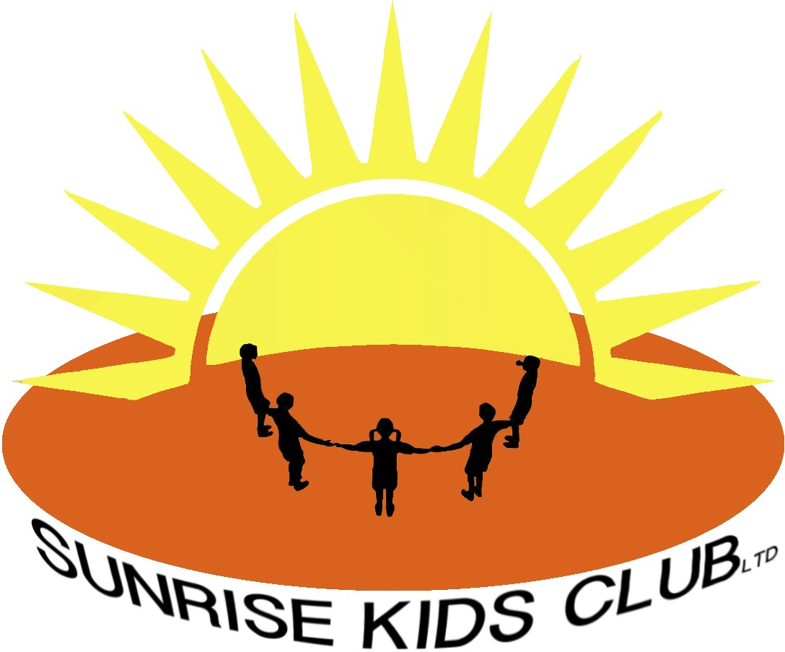
Health and Safety Procedure

Sunrise Kids Club (SKC) has a health & safety procedure, which is monitored and reviewed every two years. Staff are made aware of their responsibilities for health and safety of themselves and children in their care. Risk assessments/policies for procedures and activities at the club are reviewed as and when incidents arise and reviewed formally on an annual basis. The health and safety lead is the club manager Jacqui Foote, however any member of the team can complete these assessments and the findings must be reported to the manager and filed in the relevant folder.
SKC’s policies and procedures are there to support members of staff and are made available for parents/carers to view.

First Aid
3 members of SKC staff are first aid trained. In SKC there will always be a paediatric first aid trained member of staff available. A first aid kit is always situated within the SKC working area.

Fire Safety Drills & Emergency Evacuation Procedure
Regular fire drills are practiced to ensure efficient and effective evacuation from the building.
In an emergency, the fire alarm will sound (a continuous audible siren) and all children and staff will leave SKC premises together through a designated fire exit route to the assembly point in the lower playground. An SKC staff member will conduct a registration to account for all the children attending the club on that day.

Site Security
- Gates should be locked except at the start of and end of the day.
- Doors should be closed to prevent intrusion but to facilitate smooth entrance and exits for approved personnel.
- Children will only be allowed home with adults with parental responsibility or confirmed permission.

Outside Play Area
Staff must conduct a health and safety check around the outside play space before children are allowed access.

Equipment
During activities, all staff members are required to be vigilant of the resources and equipment in use. Any broken or damaged equipment must be removed or replaced and reported to a senior member of staff.

Hazardous Substances
Cleaning equipment and fluids are stored safely and securely as per Control of Substances Hazardous to Health (COSHH) guidance. These are always kept out of the reach of children. All staff are provided with appropriate Personal Protective Equipment (PPE).

Food Handling
Staff members who handle food are required to attend food hygiene training and to follow good practice at all times. (see also Food & Drink policy)

Accident Record
Any accidents with either children or staff must be recorded in the relevant Accident record form. (see Accident and Illness/Injury Policy)

Reviewed January 2026

