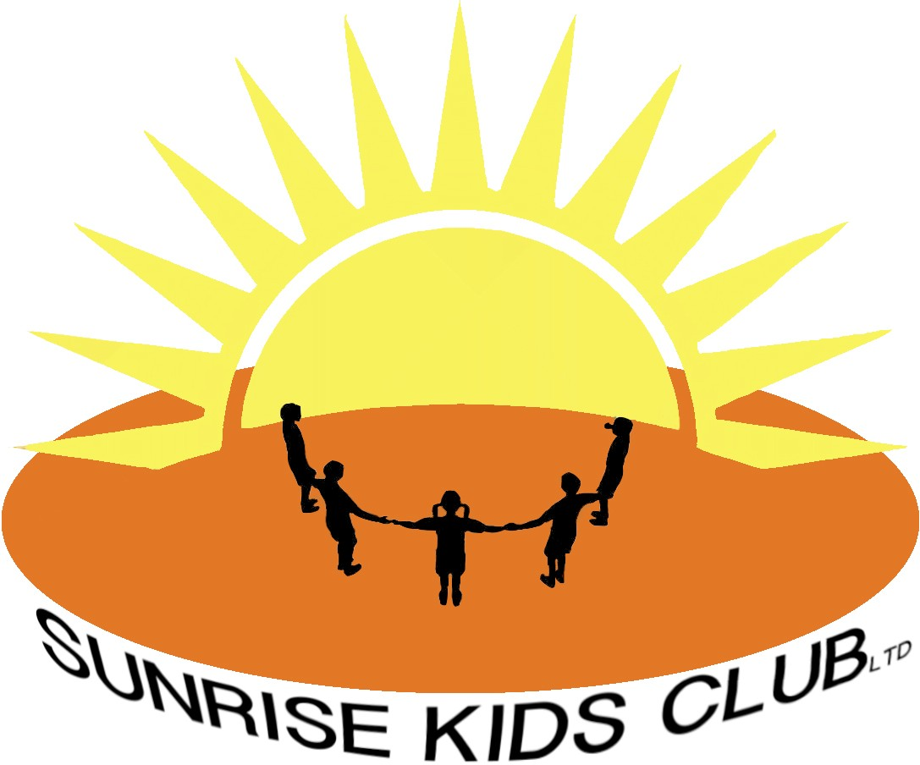

Drug and Alcohol Policy

Sunrise Kids Club (SKC) does not condone the use of drugs and/or alcohol by staff nor the illegal supply of these substances.

In addition to the prohibition of drugs and alcohol, SKC has a no smoking ethos as this will also have an indirect impact on the health of the children within our care.

The club is committed to the health and safety of its staff and children and will take appropriate action to safeguard their well-being (see Safeguarding Policy).

SKC acknowledges the importance of its pastoral role in the welfare of children and young people, and adheres to the principals of safeguarding and every child matters policy.

Reviewed January 2026

